RaonAtti International Coordinator Meeting
Living a Modest Lifestyle: A Challenge for the New Generation
by Patcharin Aviphan, YMCA of Chiang Mai
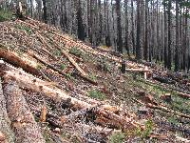
There are many problems in the world today facing human beings. Global problems like poverty, spreading of disease, food and water shortages affect many people and bring conflict over natural resources, but not wealthier countries. However, there are certain problems that humans from every nationality, race, religion and class must face and must work together in order to find a solution.
The world’s current financial crisis has affected people from the United States to Iceland to France to China to Zimbabwe. Some economists have blamed excess production, excess consumption and an overestimate of demand and profits. Though it is unclear what the causes of this economic fall are, it is clear that many people will now have to cut back on their spending, especially that of luxury goods that aren’t necessary to our survival.
Luxurious living has brought airplanes, highways, telephones and electricity use a lot of our natural resources. Though our new way of life is comfortable, we have fallen out of balance with nature and have caused future generations many problems that they will have to live with.
One of the Earth’s Biggest Problems: Global Warming
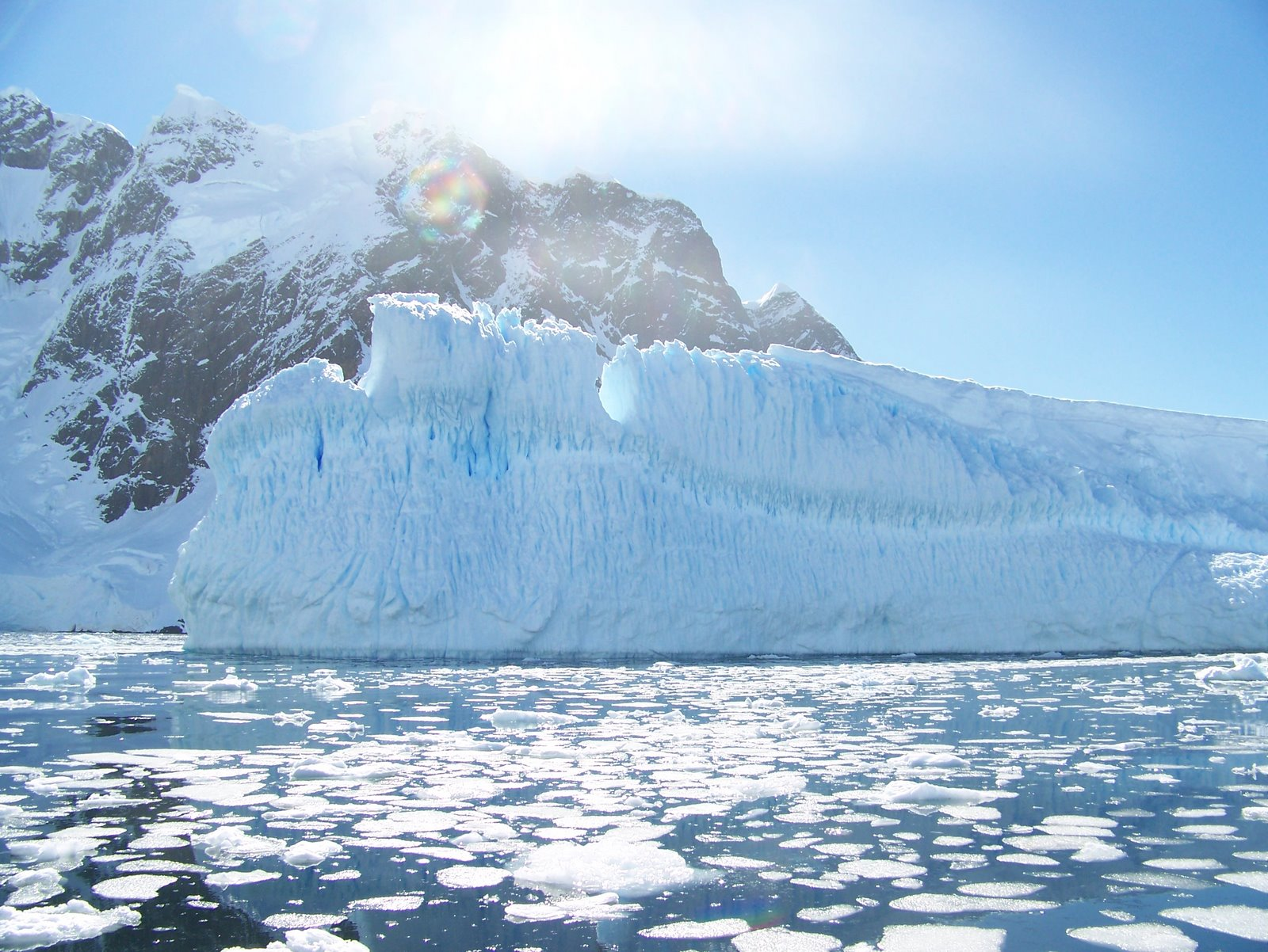
Living in today’s modern times, we have been over-consuming natural resources like petrol, water and trees that has seriously damaged the health of our planet and our home. By being irresponsible, we have all done things that could have been prevented that have contributed to global warming. We can see that during the past 20 – 100 years the world has changed more rapidly than it has in the last 1,000 years. Now, with the age of industry which uses more resources, things are changing and becoming worse.
One of the biggest impacts of globalization and economic development is global warming. Like the film, “An Inconvenient Truth” the fact that our fast-paced lifestyle is hurting our chances of continuing life here on Earth is true. Even though we don’t all live in an industrialized nation, everyone is affected by the actions of everyone else. The effects of global warming hurt everyone.
As a global community, we have to realize and understand these problems and know how to respond. We have to act, not just talk, in order to reduce the effects of global warming. Since our day-to-day lives produce Green House Gases (GHGs), especially with the expansion of industrialization that has increased transportation and energy consumption as well as wasteful, luxurious lifestyles increase GHGs like carbon dioxide, methane, nitrous oxide and chlorofluorocarbon. With the increase of the Greenhouse effect, the radiation from the sun cannot reflect back into space, thus raising our global temperature and causes climate change.
Effects of Global Warming
There are 10 major problems resulting directly from the effects of Greenhouse effect, global warming
- Glacier melting – The oceans are rising because more water is being added to them due to our new hot temperatures melting the glaciers.
- Antarctic and Arctic ice sheets melting –Today, the ice at the North Pole is melting and if the ice continues to melt at the poles, many of Earth’s beautiful coastal cities will soon be underwater.
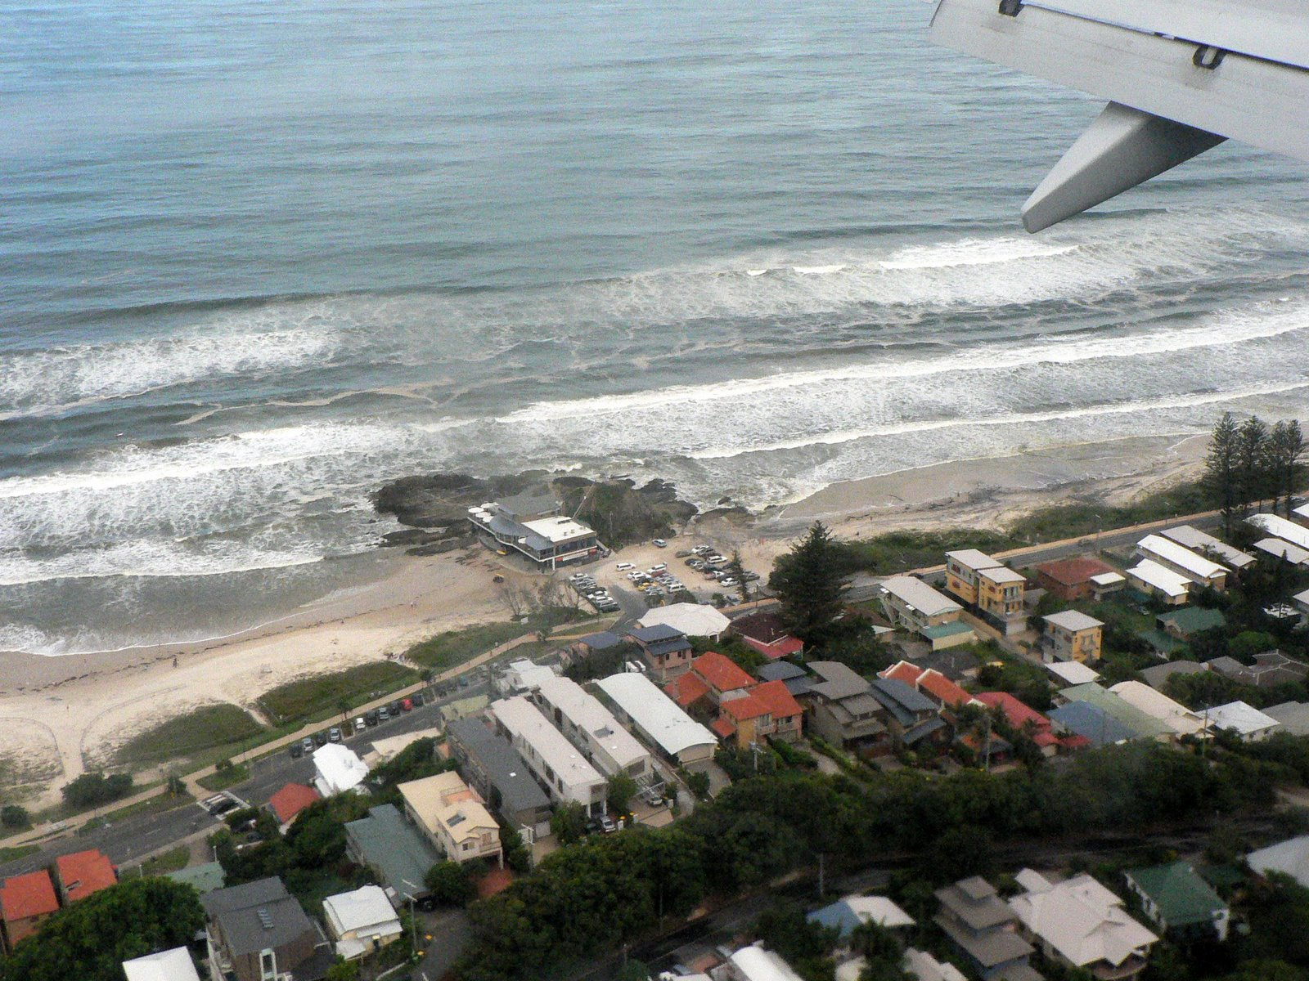
- Sea levels rising – As the sea levels rise, land disappears along with the homes built on that land. Many countries had suffered from this as they lose their coastal areas and islands as the waves continue to hit the shore further inland every day.of life on Earth, the seasons will unnaturally change due to increasing of temperature.
- Spread of diseases – With the water rising and forests being cut down, animals will adapt and will live closer to humans. Many of these animals bring new diseases previously unknown to the human population
- Extinction – The more forests we clear and as more glaciers melt, animals and plants are displaced and may ultimately become extinct.
- Coral Reef Bleaching – The once beautiful underwater forests of coral that supported aquatic life are dying.
- Storms – With the disruption in our ecosystems, heavy rains bring flash floods and landslides. Thailand, many countries in Asia, Europe and America have suffered from serious storms and floods.
- Heat waves – Countries across the world have suffered from the newly created temperatures. Many people die from the intense heat and sudden lack of water.
- Drought – As parts of our world become flooded, other parts are drying up. The lack of water leads to the inability to grow crops, food shortages and also brings forest fires.
Things We Can Do
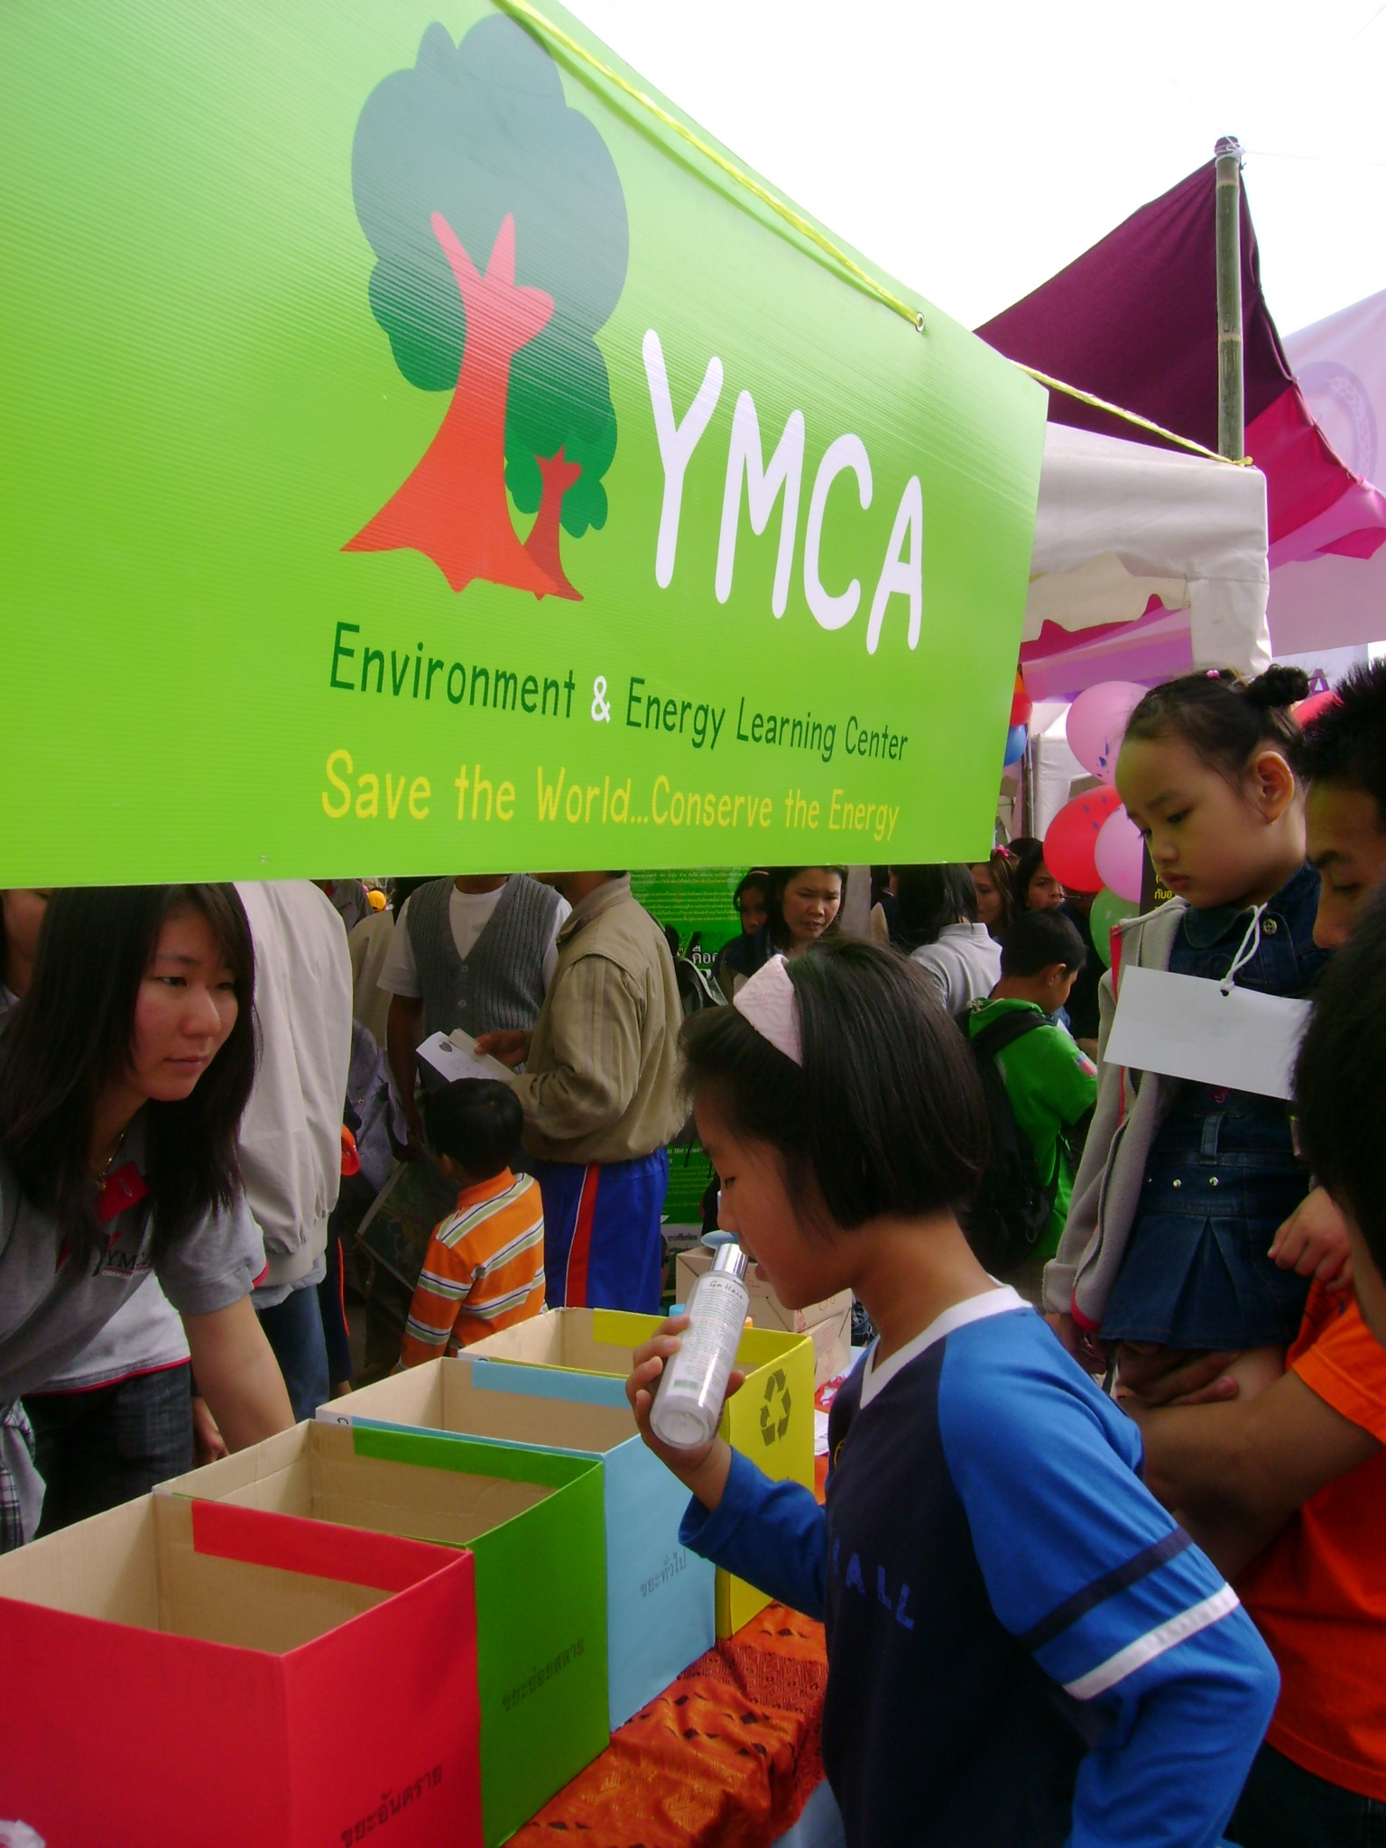
- Educate others and raise their awareness of the problems we are causing and the devastating outcomes that will surely follow.
- Change our lifestyle by living simply and by consuming as least as possible.
- Use natural resources responsibly and wisely.
- Work together by cooperating with others to save the planet.
- Encourage our governments to pursue using alternative energy sources that have low or no carbon emissions.
- Support organic agriculture by purchasing produce grown without the use of chemicals.
- Look for green products when buying household supplies.
- Conserve energy by using solar energy, biogas, etc. at home.
- Take care of the environment and live more harmonious with nature.
- Develop ourselves morally and spiritually in order to emphasize with the condition of our planet and bring peace to the world.

There are also many practical things you can do at both home and work and regarding our transportation and consumption habits. Things like: keeping the lights turned off during the day and only use natural light, put you computer in sleep mode when not using it, unplug appliances, simply open a window instead of using an air conditioner, use reusable containers instead of paper plates or Styrofoam containers, don’t keep your car running if you’re parked, use a bicycle or walk instead of driving when going short distances and use cloth, reusable bags instead of accepting plastic bags from the grocery store or market.
Sustainable Development
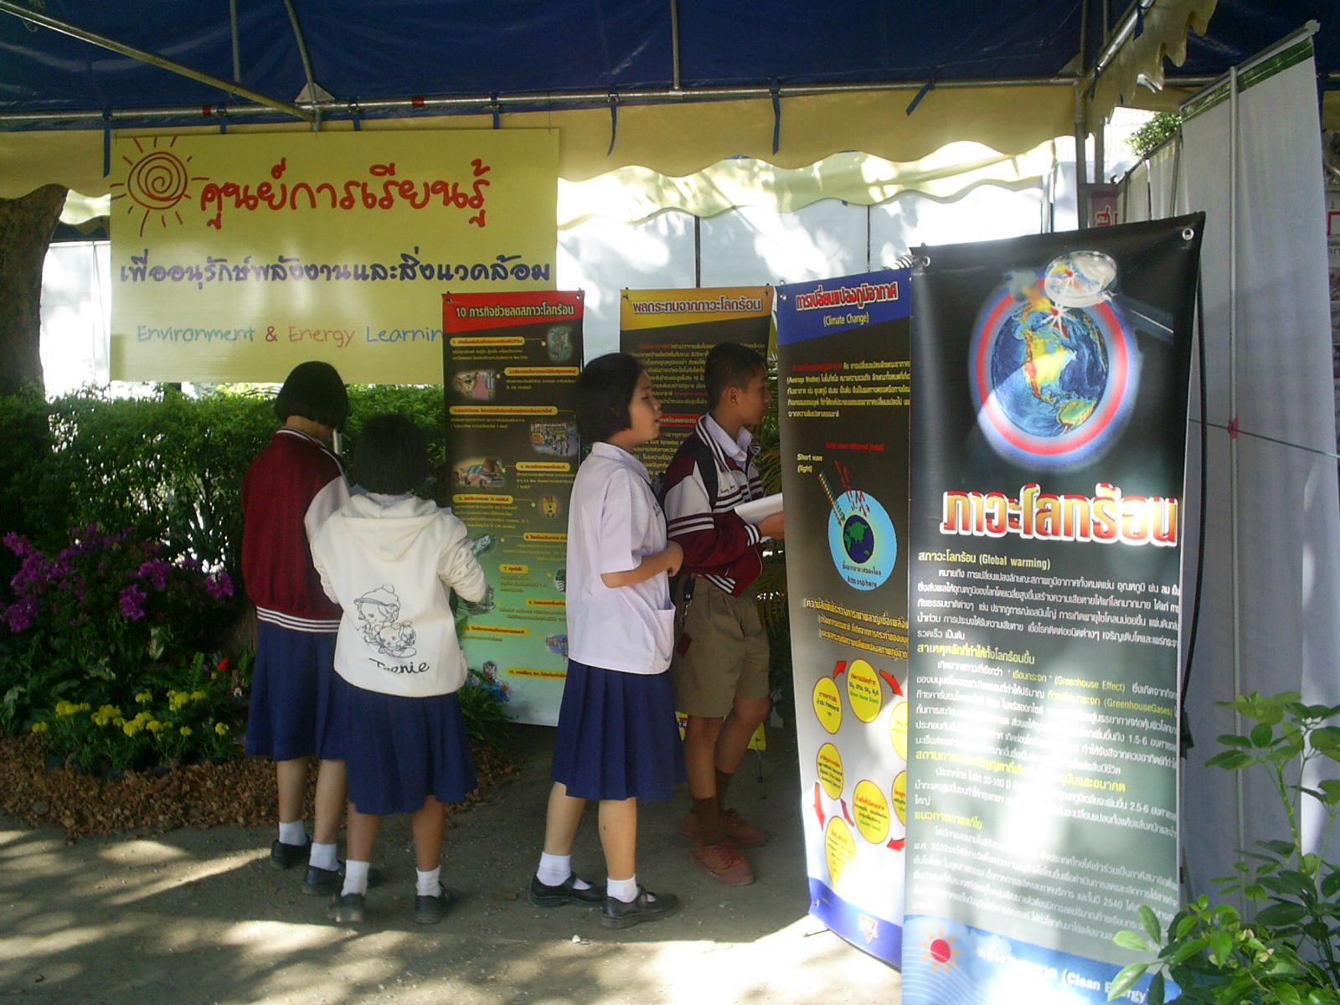
The concept of sustainable development is to meet the needs of the present without compromising the ability of future generations to meet their own needs. If we continue along the path of wasteful habits without thinking about our children’s needs, we will irreversibly hurt their futures. By following the ideas of action mentioned above, we can move towards environmental renewal and away from environmental degradation.
Instead of only passively watching the situation occur and not take action, we should actively protect our natural resources, thusly protecting our community and our world.

Networking and Cooperation.
The YMCA cannot slow down global warming’s rapid pace alone. YMCAs from all countries to join other organizations, universities and businesses who are already involved in sustainable development, environmental preservation and/or energy conservation activities. Plus, inform other who are not yet involved about the YMCA’s programs and encourage them to get involved.
We should also have clear steps of action to achieve our goals. Different sets of rules or guidelines should be implemented that will fit with the situation of your community or organization. For example, a company may pledge to turn off business equipment when it’s not in use and a forest village may pledge to replant the trees they have cut down.

And youth volunteers, YMCA members and staff should be the first to implement the new guidelines and set the example for others. Global warming has no international borders and we must recognize it as a global problem and not just that of industrialized nations.

Only if human beings join together will we be able to save our home planet.

----------------------------------
The YMCA of Chiangmai
Sao Hin YMCA , 103 Kor Klang Rd, Chiangmai 50000, Thailand
Tel 66 53 140162, Fax 66 53 140164
Email; yfcmth@yahoo.com

